First Century Living: Understanding the Background of Revelation
Shane J. Wood
Prague, Czech Republic,
October 2008

- The Importance of Understanding the Historical Background
  - This was written to real people, in a real place, in a real time, by a real person.
- The Historical Setting of Revelation Can Be Summarized With One Word: CONFLICT
  - Conflict – when two people or two kingdoms try to occupy the exact same space at the exact same time.
  - How do we know there is conflict in Revelation?
    - There are over 95 passages that refer to conflicts and/or oppositions.
      - Rev. 1:9; 2:2, 3, 4, 5b, 6, 7b, 9, 10, 11, 13, 14, 15, 16, 17b, 19b, 20-23, 26; 3:3, 9, 12, 16; 5:6, 9, 12; 6:2, 4, 6, 8b, 9, 11, 12-17; 7:2b, 14b; 8:5, 7, 8-9, 10-11, 12; 9:3-11, 15-19; 11:2b, 5, 7, 10b, 13, 18; 12:4, 7, 8-9, 12b, 13, 15-16, 17; 13:6, 7, 10b, 15, 16-17; 14:8, 9b-11, 12, 13a, 19-20; 16:1, 2, 3, 4, 5b, 6a, 6b, 8-9, 10-11, 14b, 19b; 17:6, 14, 16; 18:8b, 20b, 21, 24; 19:2, 15, 17b-18, 19, 20b-21; 20:2-3, 4a, 7-8, 9b, 10, 15; 22:18, 22.19.
    - Refer to the Maps of: The Roman World and the Spread of Christianity in the Roman World.
  - Who is in Conflict and Why?
    - God and Satan
      - There are two kingdoms that are trying to occupy the same space at the same time – people on earth in the 1st century.
    - Christians and…
      - Jews in the Roman Empire
        - History of the Jewish Persecution
          - Jews use Rome to destroy Jesus (cf. Matt. 12:14; 21:33-46; 26:4; Mark 11:18; 12:1-12; 14:1; Luke 19:47; 20:9-19; John 5:18; 7:19, 25; 8:37, 40).
          - Jews persecute early Christians (cf. Acts 7:54-60; 8:1-3; 9:1-6).
          - Jews persecute Paul and his companions (cf. Acts 17:5-9, 13-15; 18:6; 21:27-36; 23:1-11, 12-22).
          - Jews persecute Christians in Asia Minor, as recorded in the book of Revelation (cf. Rev. 2:9, 14, 20-24; 3:9).
        - Reason for their Persecution
          - Christian Message
          - Christians and Synagogues (cf. Acts 9:20; 13:5, 14, 42; 14:1; 17:1-2, 10, 17; 18:4, 19, 26; 19:8).
          - Christians were attempting to occupy the same space at the exact same time.
        - Result
          - Jews attempt to destroy Christianity through:
            - Leading them astray (2 Thess. 2:1-3)
            - Stirring up trouble for them (Acts 17:5, 13)
            - Killing them (John 19:6-16; Acts 7:54-60)
          - The problem was that the Jews did not have the power to kill (although they found ways at times). How did they accomplish this ultimate goal?
      - Imperial Cult
        - Definition – Worshipping the emperor as a god
        - Origin – Used as a political tool to unify a diverse empire
        - Perversion of the System
          - Caligula (A.D. 37-41)
          - Nero (A.D. 54-68)
          - Domitian (A.D. 81-96)
        - The Essence of the System (Empire-wide) – As a part of the Roman Empire, you can worship as many other gods as you want, but all will worship the empire as the supreme god.
        - The Essence of the Problem between the Roman Kingdom and the Kingdom of Christ
          - The kingdom of Rome and the Kingdom of Christ are trying to occupy the exact same space at the exact same time – people on earth in the 1st century.
      - Roman Society
        - Christians were accused by the Roman Society at large of being:
          - Cannibals
          - Incestuous
          - Atheists
          - Anarchists
    - Result of these conflicts
      - Christians were seen as a subversive threat to the prosperity of the Roman Empire and the unity of Roman society.
      - They were dealt with harshly.
  - What does the Conflict Look Like?
    - Physical Persecution
      - Oaths/Decrees of Rome – Roman Empire unified under pledges to keep the empire pure of dissension.
      - Polycarp (A.D. 69-155) – Bishop of Smyrna martyred for his faith in Christ.
      - Biblical Texts (Matt. 5:11-12; Acts 5:17-41; Romans 5:1-5; 2 Cor. 2:3-11; 1 Thess. 1:6; 2:2, 14; 2 Thess. 1:5, 8; 1 Pet. 4:16; Rev. 1:9; 2:10ff.)
    - Non-Physical Persecution
      - Slander – See “Roman Society” above.
      - Attempts to Deceive Christians with False Teachings (2 Thessalonians 2:1-3; 3:17)
      - Social Seduction – Pressure from society to compromise (Thyatira - Rev. 2:18-29; Laodicea - 3:14-22)
- Conclusion – We have victory through suffering (Rev. 13:10a; 12:11; 13:10b)

The Roman Empire
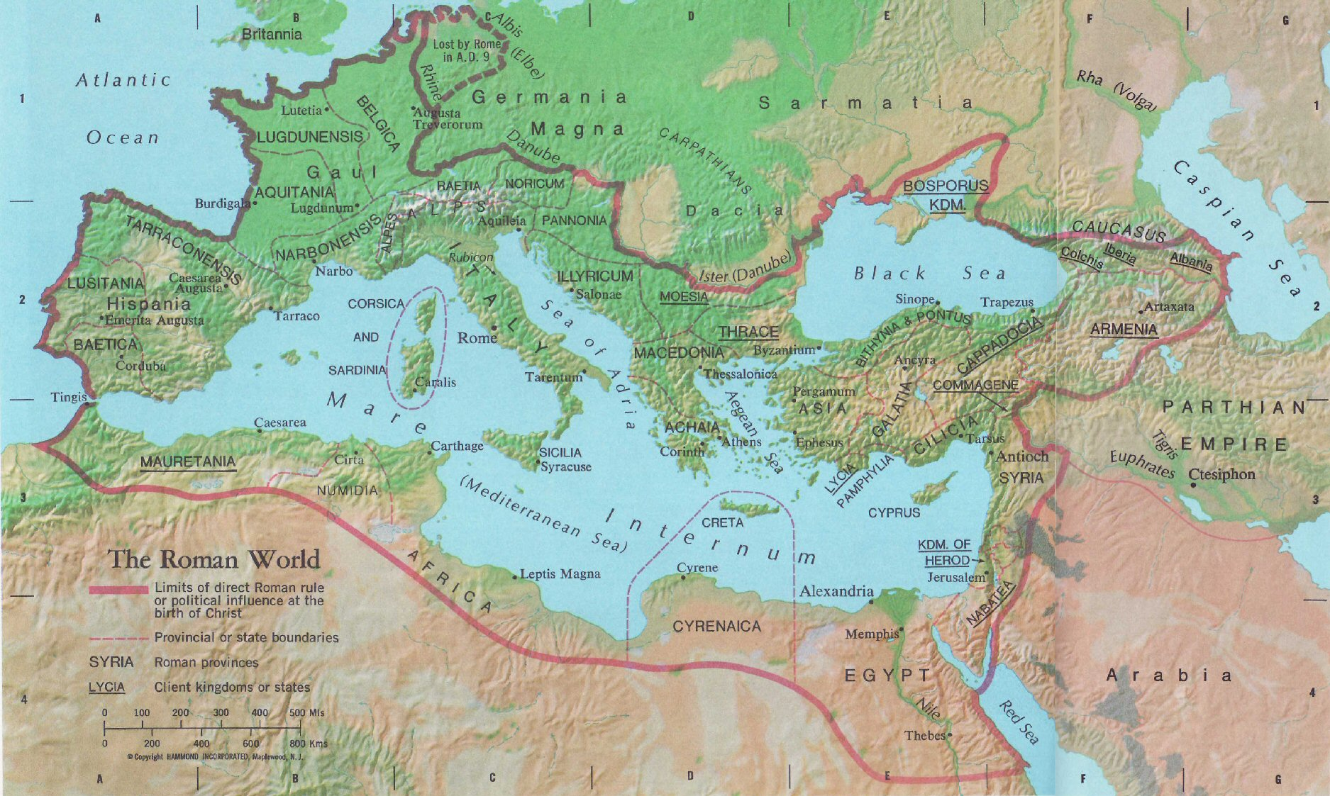
From
Harry Thomas Frank (ed.), Atlas of the Bible Lands, rev. ed. (New Jersey: Hammond, 1997): 24-25.

The Spread of Christianity in the Roman World
From
Harry Thomas Frank (ed.), Atlas of the Bible Lands, rev. ed. (New Jersey: Hammond, 1997): 24-25.

